Paper Title (Times New Roman 18 points)
Author Name ¹, Author Name ^{2,*}

¹Author(s) Affiliation(s); email@univ.ac.kr
²Author(s) Affiliation(s); email@university.edu

*Corresponding author.

Abstract
The abstract summarizes the paper's content and appears below the author’s information. Title its “Abstract” in 11-point bold italicized Times New Roman, centered, and initially capitalized. Use 10-point italicized, single-spaced text for the content. Leave one blank line after the abstract before the keywords. Manuscripts must be in English.
Keywords- Computing, Communication, Information.

- Introduction
This template, updated in the latest MS Word format, provides authors with essential formatting specifications for preparing electronic papers. It ensures (1) easy formatting, (2) compliance with electronic publication standards, and (3) consistency in conference proceedings. Margins, column widths, line spacing, and type styles are pre-set, with examples indicated in italics. While elements like equations, graphics, and tables are not predefined, relevant text styles are included for guidance.
- Prepare Your Paper Before Styling
Before you begin to format your paper, first write and save the content as a separate text file. Keep your text and graphic files separate until after the text has been formatted and styled. Do not use hard tabs, and limit use of hard returns to only one return at the end of a paragraph. Do not add any kind of pagination anywhere on the paper. Do not number text heads-the template will do that for you.
Finally, complete content and organizational editing before formatting. Please take note of the following items when proofreading spelling and grammar:
- Equations
Equations must follow the template's specifications. Use only Times New Roman or Symbol font. For complex equations, insert them as graphics. Number equations consecutively, aligning numbers flush right in parentheses (e.g., (1)). Use the solidus (/), exp function, or exponents for compactness. Italicize Roman symbols for variables but not Greek symbols. Use a long dash for minus signs and punctuate equations when part of a sentence.
The equation should be written by using MS word as follows:

${\left(x+a\right)}^{n}=\sum_{k=0}^{n}{\left({n \atop k}\right)x^{k}a^{n-k}}$ (1)

Note that the equation is centered using a center tab stop. Be sure that the symbols in your equation have been defined before or immediately following the equation. Use “(1),” not “Eq. (1)” or “equation (1),” except at the beginning of a sentence: “Equation (1) is ...”
- Using the Template
After the text edit has been completed, the paper is ready for the template. Duplicate the template file by using the Save As command and use the naming convention prescribed by your conference for the name of your paper. In this newly created file, highlight all of the contents and import your prepared text file.
- Figures and Tables

Positioning Figures and Tables: Place figures and tables at the top and bottom of columns. Avoid placing them in the middle of columns. Large figures and tables may span across both columns. Figure captions should be below the figures; table heads should appear above the tables. Insert figures and tables after they are cited in the text. Use the abbreviation “Fig. 1,” even at the beginning of a sentence.
Table 1. Table caption
Table Column Head

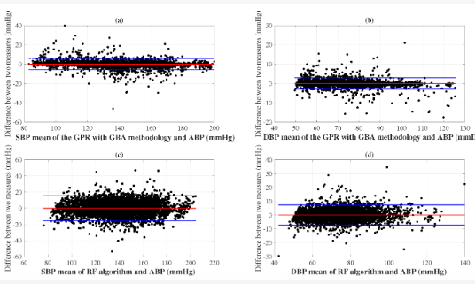
Fig. 1. Figure caption.

All figures and tables should be numbered and the appropriate space reserved in the text, with the insertion point clearly indicated.
Acknowledgment
The preferred spelling of the word “acknowledgment” in America is without an “e” after the “g.” Avoid the stilted expression “one of us (R. B. G.) thanks ...”. Instead, try “R. B. G. thanks...”. Put sponsor acknowledgments in the unnumbered footnote on the first page.

References
[1] Al-Otaibi, S., Al-Rasheed, A., Mansour, R.F., Yang, E., Joshi, G.P. and Cho, W., 2021. Hybridization of metaheuristic algorithm for dynamic cluster-based routing protocol in wireless sensor Networksx. IEEE Access, 9, pp.83751-83761.
[2] Mansour, R.F., Abdel-Khalek, S., Hilali-Jaghdam, I., Nebhen, J., Cho, W. and Joshi, G.P., 2023. An intelligent outlier detection with machine learning empowered big data analytics for mobile edge computing. Cluster Computing, pp.1-13..

